**# To-Do List Application Using Java**

* Overview:

The To-Do List Application is a simple yet effective program designed to help users manage their tasks efficiently. Built using Java, the application offers essential functionality to add, edit, remove, view tasks, and exit the program seamlessly. This lightweight application provides users with a straightforward way to organize their daily activities.

* Features:

1. Add Tasks: Users can add new tasks to their to-do list.

2. Edit Tasks: Modify existing tasks to update details or correct errors.

3. Remove Tasks: Delete tasks that are no longer needed.

4. View Tasks: Display all tasks currently on the list.

5. Exit: Close the application safely.

* Technology Stack:

- Programming Language: Java

- IDE: Any Java-supported IDE (e.g., IntelliJ IDEA, Eclipse, NetBeans)

- Storage: ArrayList or similar data structure to manage tasks in memory

* How It Works:
* Menu Options

The application provides a menu-based interface for user interaction:

1. Add Task: Prompts the user to enter a new task, which is added to the task list.

2. Edit Task: Allows the user to select a task and update its details.

3. Remove Task: Enables the user to delete a specific task by selecting its index.

4. View Tasks: Displays all tasks currently in the list, showing task numbers and descriptions.

5. Exit: Safely terminates the program.

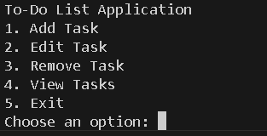

* Implementation Details:

- Data Structure: Tasks are stored in an ArrayList for dynamic management.

- Error Handling: The program validates user input to prevent errors like invalid task numbers or empty inputs.

- Modularity: Each function (add, edit, remove, view) is implemented in a separate method for better readability and maintenance.

---

* Future Enhancements:

- Add persistent storage (e.g., file or database) to save tasks permanently.

- Enable priority levels for tasks (e.g., High, Medium, Low).

- Implement a graphical user interface (GUI) using JavaFX.

- Add notifications or reminders for tasks with deadlines.

* CODE:

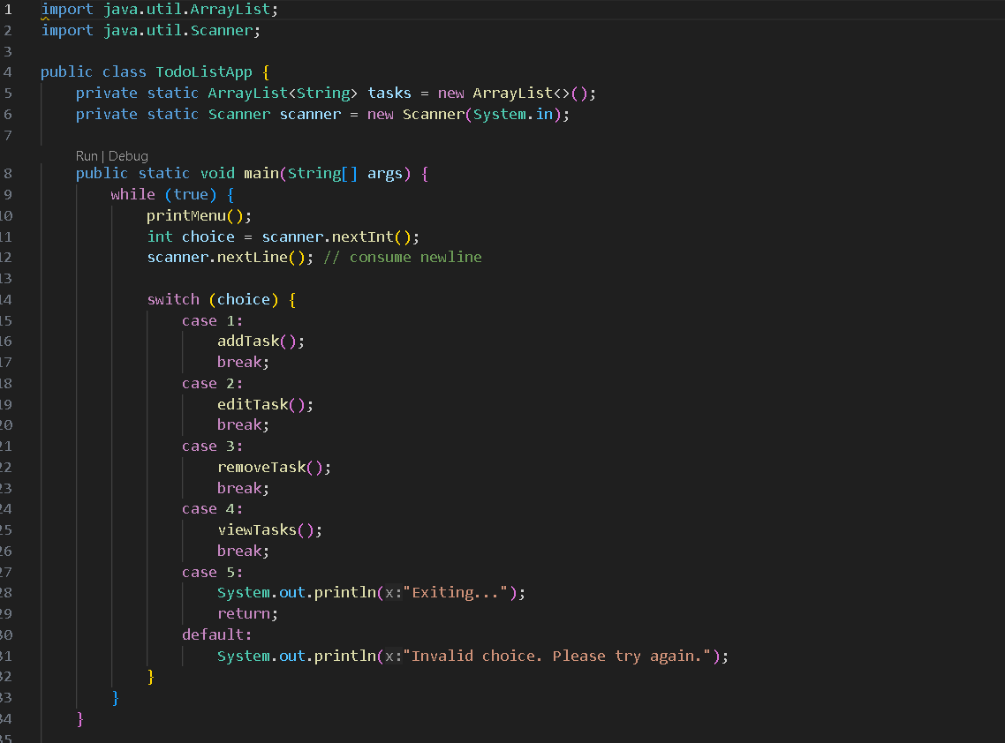

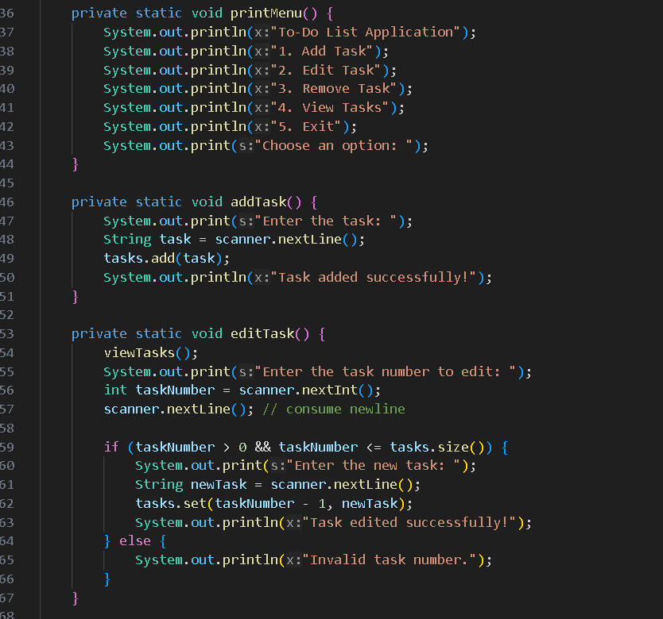

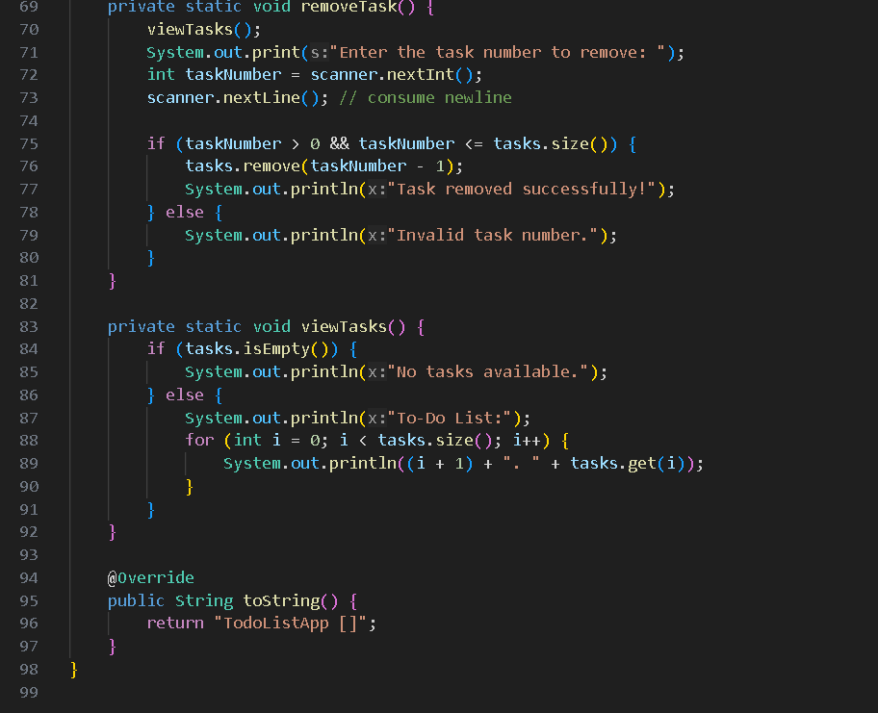

* Conclusion

The To-Do List Application in Java is a simple and efficient project to practice fundamental programming concepts such as control structures, data structures, and modular programming. It serves as an excellent starting point for building more advanced task management applications.